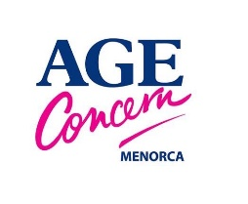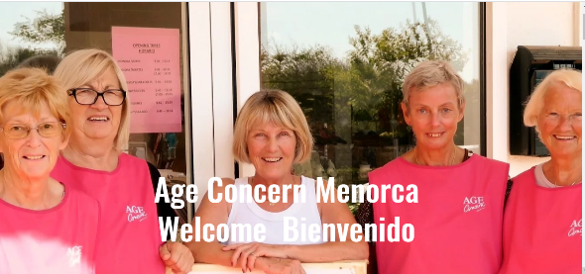
Roqueta June 2021
We’ve been very busy in the shop recently. We have been lucky enough to have been given some very special and unusual clothing, furniture and household items, for example a telescope, animal shaped painted shelves, a large jade Buddha, signed copies of cookery books, fantastic hand-made throws ….. Do come and have a look, you’ll be surprised at what you find. Come in and pick up your free Menorca 2021 calendar too – there might only be half a year left but the photographs alone are worth displaying.
Lifeline has continued to be very busy. We currently support 17 individuals on the island in different ways and we are determined to be there for anyone who needs this service from us.
The medical equipment loan service has continued to be busy too.
Membership is still thriving. Please contact our Membership Secretary if you would like to support us by becoming a Friend.
We are still not running any social activities but we hope to return to the normal pattern of two lunches a month, two ‘drop-ins’ every week and 3 or 4 day trips a year as soon as it is practicable.

Of course, we would not be able to do any of the above without your support through donations, purchases, membership or as a volunteer. In total we have about 30 volunteers at present, carrying out different roles.
So, who volunteers and what do they do?

Christine and Jaume
Christine has worked as a volunteer in the shop for several years and has also, for the past two years, worked with Lifeline. Christine first volunteered for Age Concern about 30 years ago, ironing and preparing clothing for sale at the shop we then had in Es Castell. She stopped when work commitments made it too difficult. For the last six years or so she has volunteered in the shop winters only but since she retired in 2020 she has worked with us all year round. At about the same time, Christine started working with Lifeline too, supporting individuals, mainly with official paperwork, translations etc. Christine has been part of the Age Concern Executive Committee since last year.
Christine has always worked in people related professions. She first came to Menorca in 1974 to work as a ‘Girl Friday’ for ‘Beach Villas’. She moved to Menorca in 1991 and married her Menorcan husband here in 1993.
What Christine likes most about volunteering with Age Concern is: “You can see that Age Concern is actually doing what is says it does – it really helps people. You see positive results first hand.”
Jaume is Christine’s son. He was born here and has lived here all his life. Jaume’s ambition is to make a career for himself in the tourist industry here in Menorca and become an official tourist guide. He’s keen to improve his already good knowledge of the history, culture and geography of the island and is also developing his knowledge of business and marketing. Due to the coronavirus situation. Jaume had time free and knew that Age Concern needed more strong volunteers to help with the collection of furniture and other large donated items. He is currently volunteering one or two mornings a week to help in this area. He enjoys volunteering with us, especially practising his English, travelling around the island and finding new locations, meeting new people and working with others.

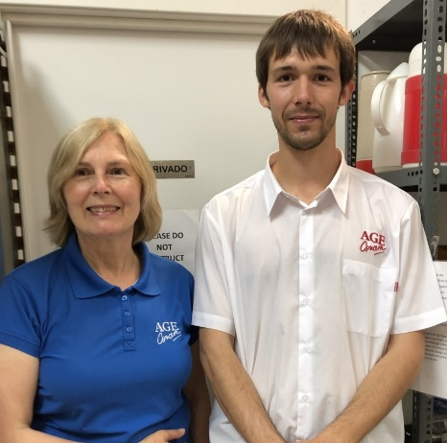

Key information:

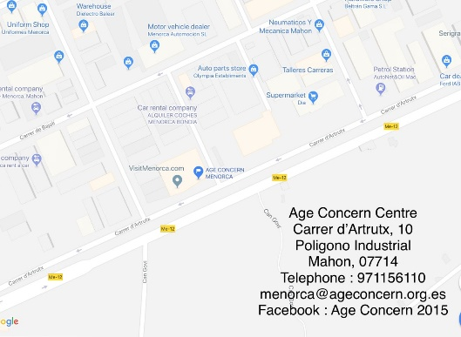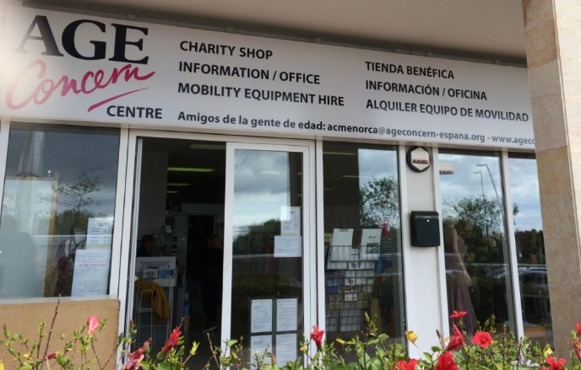

Opening hours: Monday – Saturday, 9.45 – 13.15. (closed afternoons until further notice)

Contact us: For the latest information and current offers follow us on Facebook or visit our website.

General email | menorca@ageconcern.org.es
Visit our Website | www.ageconcernmenorca.com
Follow us on Facebook | Age Concern Menorca 2015
Social Secretary | menorca@ageconcern.org.es 699 901 777
Membership Secretary | menorca@ageconcern.org.es 620 017 437
Lifeline | lifelineac@yahoo.com 676 904 487
Medical & mobility equipment loan  BY APPOINTMENT ONLY | acmenorcamedequip@gmail.com 629 016 307
Shop | menorca@ageconcern.org.es 971 156 110
Trips | lindahart.outings@gmail.com 971 156 110

